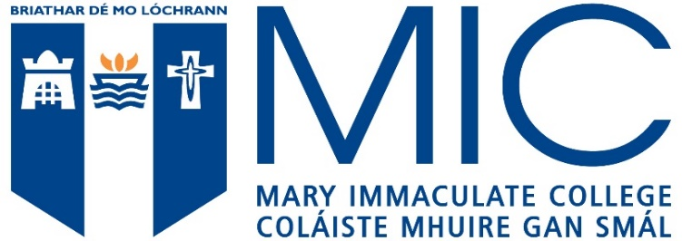

Mary Immaculate College students must have a high level of competence in the English language. Applicants whose first language is not English must provide evidence of this competence by achieving the minimum standard in a recognized English language test, as outlined below:-

MATRICULATION EXAMINATIONS | From European countries where English is presented as a subject and an acceptable level is achieved
IRISH LEAVING CERTIFICATE ENGLISH | Ordinary Level Grade D or above
TOEFL | 580 (paper based) or 90 (internet based)
IELTS | Minimum score of 6.5 with no less than 6.0 in any component.
ETAPP) ENGLISH TEST FOR ACADEMIC AND PROFESSIONAL PURPOSES | Grade C1
GCE ‘O’ LEVEL ENGLISH LANGUAGE/ GCSE ENGLISH LANGUAGE | Grade C or above
UNIVERSITY OF CAMBRIDGE ESOL | Proficiency Certificate, Grade C or better (CEFR Level C1 or C2) or Advanced Certificate, Grade C or better (CEFR Level C1 or C2) or First Certificate, Grade A (CEFR Level C1)
GCE EXAMINATION BOARDS | Oxford Delegacy of Local Examinations - Grade C / Cambridge Local Examinations Syndicate - School Certificate Pass 1-6 /  University of London Entrance and School Examinations Council - School Certificate Pass 1-6
PEARSON TEST OF ENGLISH (PTE) ACADEMIC: | a minimum score of 61 (with no section score below 59)
OXFORD ENGLISH TEST | Overall minimum 140. Individual skills 125
LANGUAGE CERT ESOL | B2 Communicator High Pass with no less than 33 in each skill
DUOLINGO ENGLISH TEST (DET) | The minimum requirement will be a DET score of 120 with at least 110 in each sub score.  An Interview may be required in addition to this.

European Union applicants must apply to Mary Immaculate College via the Central Applications Office (CAO).

